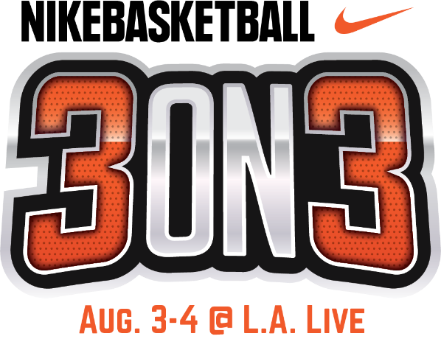

11TH ANNUAL NIKE BASKETBALL 3ON3 TOURNAMENT AT L.A. LIVE CONCLUDES WITH OLYMPIC HOPEFULS ONE STEP CLOSER TO 2020 TOKYO GAMES

Men’s Nike Elite Division Champions
Advance to FIBA Edmonton Challenger

Women’s Nike Elite Division Champions Advance to
Women’s Regional USA Basketball Tournament in Los Angeles

LOS ANGELES (August 4, 2019) – The 11th Annual Nike Basketball 3ON3 Tournament at L.A. LIVE brought more than 1,500 teams and 6,000 players from around the country to compete in nearly 1,500 games and concluded this afternoon with the winning teams from both the men and women’s Nike Elite Divisions moving one step closer to achieving their Olympic dreams.

For the first time in the Nike Basketball 3ON3 Tournament’s history, the Men’s Nike Elite Division served as an official International Basketball Federation (FIBA) 3X3 Satellite Tournament, with the winners guaranteed an entry into FIBA’s upcoming Edmonton Challenger event on September 28-29; there they can ultimately qualify to advance to the FIBA 3X3 World Tour Nanjing Masters in China on October 12 and 13 – bringing them one step closer to their Olympic dreams of representing the USA in Tokyo during the debut of FIBA 3x3.

The Men’s Nike Elite Division was won for the first time by team THREEBALL Minnesota consisted of players Brensley Haywood (29th*), Eric Coleman (90th*), Kurtis Koenig (38th*) and Paris Kyles.

The Women’s Nike Elite Division, which served as a qualifier for the Women’s Regional USA Basketball Tournament in Los Angeles in September, was won by team LA Premier which consisted of Brianna Barrett, Teara Laudermill, Jordan Adams and Candice Agee.

“We’re thrilled that our tournament continues to attract talent throughout the country in addition to the attention of FIBA, who this year, designated the men’s Nike Elite Division an official FIBA 3X3 Satellite Tournament,” said Ryan Golden, Commissioner, Nike Basketball 3ON3 Tournament. “It’s an exciting time for 3x3 basketball, and even more so to realize that players from our tournament could potentially represent the USA in the 2020 Olympic Games in Tokyo.”

In addition to qualifying to each respective tournament, all team from both the men’s and women’s Nike Elite Division teams received $2,000 in American Express gift cards and $1,000 in Nike gift cards in addition to being awarded travel, lodging and meal allowances for the Edmonton Challenger and Women’s Regional USA Basketball Tournament.

Throughout the weekend, more than 5,000 players competed on the surrounding streets of L.A. LIVE and STAPLES Center throughout downtown Los Angeles in California’s largest 3-on-3 street basketball tournament, with more than 25,000 fans and spectators cheering them on.

The entertainment-packed weekend kicked off on Friday, Aug. 3 with the Tournament’s Opening Night Ceremony & Tip Off Party during Downtown Dark Nights at L.A. LIVE during which approximately 10,000 guests enjoyed the Nike Basketball 3ON3 Tournament Fan Fest, which featured Pep-Rally performances, music, street performers, food and drink specials and “Pay to Play” basketball opportunities on the main court in Xbox Plaza.

Saturday’s competition throughout the tournament’s seven divisions of play (Youth Division presented by Blue Shield of California, Teen Division presented by Big 5 Sporting Goods, Adult Division presented by US Army, Nike Elite Division, corporate challenge, wheelchair and Special Olympics) was highlighted by the fan-favorite Nike Slam Dunk Contest, which drew the largest crowds of the day as internationally known slam dunkers Michael Purdie, Elijah Bonds, Jamal Harris, Andrew McFly, Chris Staples and 2-time defending Nike Slam Dunk Contest Champion, Reemix (Myree Bowden) showed off their high-flying skills – including jumping over fans. Chris Staples took first place after receiving top marks across the board from the judges.

The 11th Annual Nike Basketball 3ON3 Tournament drew an impressive number of teams and fans and has tripled in size from its inaugural year, becoming a Southern California tradition that now attracts the best teams from around the country.

Official sponsors of the Nike Basketball 3ON3 Tournament include Nike Basketball, Big 5 Sporting Goods, Powerade, US Army, Spartan Race, Blue Shield of California, UCLA Health, Budweiser, Tequila Avión, Jameson Whiskey, and Martell Cognac.

The 12th Annual Nike Basketball 3ON3 Tournament at L.A. LIVE will take place August 8 & 9, 2020 and registration is now open at nike3on3.com.

*denotes FIBA USA ranking

About L.A. LIVE
L.A. LIVE is a 4 million square-foot, $3 billion downtown Los Angeles sports and entertainment district adjacent to STAPLES Center and the Los Angeles Convention Center featuring The Novo, a 2,300 capacity live music venue, Microsoft Theater, a 7,100-seat live theatre, a 54-story, 1001-room convention “headquarters” destination (featuring The Ritz-Carlton, Los Angeles and JW Marriott Los Angeles at L.A. LIVE hotels and 224 luxury condominiums – The Ritz-Carlton Residences at L.A. LIVE – all in a single tower), the GRAMMY Museum, the 14-screen Regal L.A. LIVE: A Barco Innovation Center theatre, broadcast facilities for ESPN along with entertainment, residential, restaurant and office space.

Developed by Los Angeles-based AEG, L.A. LIVE, considered to be the nation’s most active ‘live content and event campus,’ has become the region’s most in-demand and busiest hospitality location throughout the past 10 years, featuring 260,480 sf of conference center and ballroom facilities, world-class restaurants including WP24, Fleming’s Prime Steakhouse & Wine Bar, Katsuya, Shaquille’s, Rock ‘N Fish, Rosa Mexicano, Starbucks, Glance Restaurant, Smashburger, Live Basil Pizza, Tom’s Urban 24, Yard House, Wolfgang Puck Bar & Grill and BOCA at the Conga Room and others; 100,000 sf special events deck, the famous Lucky Strike Lanes and Lounge, the celebrity owned Conga Room, a one-of-a-kind GRAMMY Museum, saluting the history of music and the genre’s best known awards show all centered around Xbox Plaza, a 40,000 sf outdoor event space.

With Microsoft Theater and Xbox Plaza which came on-line in October, 2007, and the hotel, residential and meeting space components opened as of April, 2010 combined with the assets, resources and infrastructure of STAPLES Center and the Los Angeles Convention Center, L.A. LIVE showcases more events, award shows, sporting competitions, concerts and hospitality options than any other destination in the world.

# # #

Please use the following link to view photos from the event:
https://www.aegworldwide.com/press-center/media-asset/nike-basketball-3on3-tournament-la-live

Media Contact
Allegra Batista
abatista@aegworldwide.com
213-259-9953

