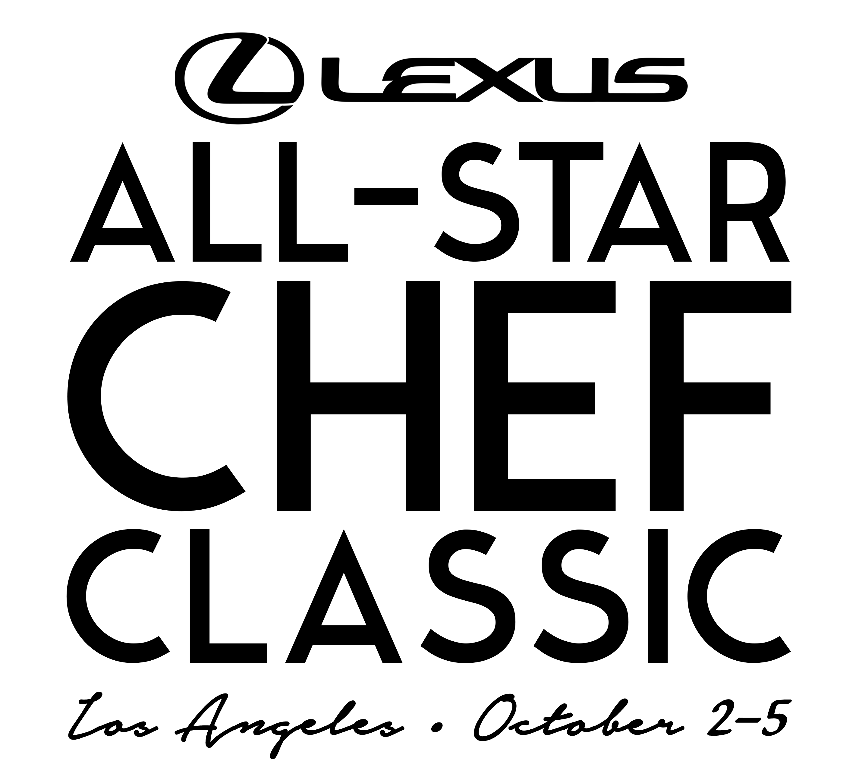

L.A. LIVE AND LEXUS ANNOUNCE
TALENT AND EVENT LINEUP FOR 2019 LEXUS ALL-STAR CHEF CLASSIC

Sixth Annual Event at L.A. LIVE Features Over 50 Award-Winning Chefs
from Across the Globe, October 2-5, 2019

LOS ANGELES, CA (June 12, 2019) – L.A. LIVE and title sponsor Lexus announced ticket sales and this year’s culinary experiences today for the Lexus All-Star Chef Classic, which will take place October 2-5, 2019 at L.A. LIVE, downtown Los Angeles’ premier entertainment district. The sixth annual event will offer fans the unique opportunity to gain exclusive access to an international roster of award-winning chefs in an unparalleled, interactive setting.
New this year, Lexus All-Star Chef Classic will expand its footprint throughout L.A. LIVE, in addition to welcoming Lexus as the title sponsor of the four-day festival. Lexus All-Star Chef Classic’s popular strolling events will now be held in L.A. LIVE’s Xbox Plaza, while ‘Masters Dinners’ and the ‘Little Masters’ event will continue to take place at the custom-built Restaurant Stadium™ on L.A. LIVE’s Event Deck. Restaurant Stadium’s 300-plus seat venue was designed to bring fans “kitchen-side,” allowing them an intimate and memorable culinary performance and meal, prepared and presented by an all-star roster of chefs.
Lexus All-Star Chef Classic offers a series of engaging experiences for guests, from multicourse-seated dinners to themed tasting events. Throughout the weekend, each event spotlights popular and critically acclaimed chefs including Lexus Culinary Masters Daniel Boulud, Stephanie Izard, Ludo Lefebvre and Michelle Bernstein. Lexus selects each Culinary Master based on their attention to detail, passion for innovative cuisine and the amazing experiences they provide for their guests. Additional chefs featured at Lexus All-Star Chef Classic include—the renowned Andrew Zimmern, Ed Lee, Duff Goldman, Alex Raij, and Wylie Dufresne and more.
This year includes the debut of the event’s first-ever Korean Masters Dinner presented by Melissa’s Produce, Italian Masters Dinner presented by Blue Shield of California, and Carneval a new strolling event championing all things meat. Returning to the festival will be the French Masters Dinner presented by Air Tahiti Nui, BBVA Spanish Masters Dinner, Little Masters, and fan-favorite strolling event, Grill & Chill presented by Stella Artois, this time with a focused theme of seafood-driven fare. Both strolling events will include a specialty ‘vineyard’ from the Santa Barbara County Vintners Association that will feature some of the top wineries from the region.
"All-Star Chef Classic has continued to grow by increasing demand and we are thrilled to partner with Lexus to further elevate the overall culinary experience,” said Lee Zeidman, President of L.A. LIVE and STAPLES Center. "With a new home for our strolling events and exceptional chef lineup, including new talent from Lexus’ prominent Culinary Masters program, year six is shaping up to be our best yet!"

"Lexus has a long history of aligning itself with amazing epicurean experiences and the Lexus All-Star Chef Classic is an ideal space to further our culinary footprint,” says Lisa Materazzo, Lexus vice president of marketing. "We look forward to kicking off our partnership with the L.A. LIVE team and bringing these curated experiences to the savvy and impassioned diners of Los Angeles.”

Ticketing: Pre-sale tickets to the four-day culinary event for Lexus car owners began on June 10, 2019. American Express® Card Members can purchase tickets before the general public beginning today, June 12 at 10 a.m. PT through Monday, June 17 at 10 a.m. PT. Public ticket sales are available beginning June 17, 2019. Tickets for Lexus All-Star Chef Classic start at $115. For more information and to purchase tickets, please visit: allstarchefclassic.com or call 1-877-234-8425.
Group Rate: For Gold and Silver ticket buyers only, ASCC is offering a $15 per ticket discount for groups of 10+ for each strolling event. For group rate information, please call 1-877-234-8425 or sales@allstarchefclassic.com
Connect on Twitter @AllStarChefLA, Instagram @AllStarChefClassic and on Facebook: facebook.com/allstarchefclassic.

Reveling in the passion, innovation and community of great food and cooking with the industry’s most venerable personalities, the 2019 Lexus All-Star Chef Classic lineup includes:

Wednesday, October 2, 2019
French Masters Dinner presented by Air Tahiti Nui
Location: Restaurant Stadium™ at L.A. LIVE's Event Deck
Doors Open Platinum VIP 6 PM / Gold 6:30 PM/ Dinner Begins 7 PM
Prices: Gold: $295 / Platinum VIP: $425

“French Masters Dinner” features five of the world’s most acclaimed French culinary experts, as well as award-winning chef, Lexus Culinary Master and television personality Daniel Boulud. The chefs will collaborate to cook a multi-course seated dinner for guests, paired with select French wines.

Thursday, October 3, 2019
BBVA Spanish Masters Dinner

Location: Restaurant Stadium™ at L.A. LIVE's Event Deck

Doors Open Platinum VIP 6 PM / Gold 6:30 PM/ Dinner Begins 7 PM

Prices: Gold: $295 / Platinum VIP: $425

Five masters of Spanish cuisine will create high-end opportunities by bringing the country’s culinary riches to life for a delicious evening at the “Spanish Masters Dinner.” Sponsored by BBVA, a top 25 U.S. financial institution, the event showcases the extraordinary cooking traditions of Spain alongside expertly curated Spanish wines.
Friday, October 4, 2019

Korean Masters Dinner presented by Melissa’s Produce
Location: Restaurant Stadium™ at L.A. LIVE's Event Deck
Doors Open Platinum VIP 6 PM / Gold 6:30 PM/ Dinner Begins 7 PM

Prices: Gold: $295 / Platinum VIP: $425

Honoring the diversity and depth of Korean cuisine, the inaugural “Korean Masters Dinner” will feature some of the most laudable chefs across the industry using the freshest global ingredients from Melissa’s Produce, the nation’s largest specialty produce purveyor. Each chef has helped define and change restaurant culture with respect to the region; celebrating its customs while also infusing personal character and style.

Carneval
Location: Chef’s Tasting Arena at L.A. LIVE’s Xbox Plaza
VIP access 7 PM / Event Begins 8 PM
Prices: Silver: $115-$135 / Gold: $160-$180 / Platinum VIP: $300
This year’s new tasting event will feature the culinary world’s premier talent – alongside some of LA’s best chefs – presenting their inspired takes and treatment on meat.

Saturday, October 5, 2019
Little Masters
Location: Restaurant Stadium™ at L.A. LIVE's Event Deck
Doors Open 10 AM / Event Begins 10:30 AM
Prices: Child + (2) Adults: $175 / Adult Add-on: $25

Restaurant Stadium™ turns from kitchen to classroom as 200 kids learn to cook alongside Duff Goldman, one of the country’s most forward-thinking pastry chefs. With a guided, hands-on cooking lesson, “Little Masters” will help foster the next generation of All-Star Chefs.
Italian Masters Dinner presented by Blue Shield of California
Location: Restaurant Stadium™ by Blue Shield of California at L.A. LIVE's Event Deck
Doors Open Platinum VIP 6 PM / Gold 6:30 PM/ Dinner Begins 7 PM
Prices: Gold: $295 / Platinum VIP: $425

Explore the rich, bold and timeless flavors of the “Italian Masters Dinner” as five masters of Italian cuisine share cooking traditions and techniques, with dishes paired with select Italian wines.

Grill & Chill presented by Stella Artois
Location: Chef’s Tasting Arena at L.A. LIVE’s Xbox Plaza
Platinum VIP & Gold Access 6 PM / Event Begins 7 PM
Prices: Silver: $115-$135 / Gold: $160-$180 / Platinum VIP: $300

“Grill & Chill” will bring together some of the world’s best chefs to honor the popularity and appeal of open flame cooking – this year showcasing innovation with seafood, exclusively. With savory grilled samples and chilled bites, “Grill & Chill” will offer guests a tour in fresh flavors of the sea, both hot and cold.

About L.A. LIVE
L.A. LIVE is a 4 million square foot / $3 billion downtown Los Angeles sports and entertainment district adjacent to STAPLES Center and the Los Angeles Convention Center featuring The Novo, a 2,300 capacity live music venue, Microsoft Theater, a 7,100-seat live theatre, a 54-story, 1001-room convention "headquarters" destination (featuring The Ritz-Carlton, Los Angeles and JW Marriott Los Angeles at L.A. LIVE hotels and 224 luxury condominiums – The Ritz-Carlton Residences at L.A. LIVE – all in a single tower), the 14-screen Regal L.A. LIVE: A Barco Innovation Center, broadcast facilities for ESPN along with entertainment, residential, restaurant and office space. Developed by Los Angeles-based AEG, L.A. LIVE, considered to be the nation's most active 'live content and event campus,' also features 260,480 square feet of conference center and ballroom facilities, a 100,000 square feet special events deck, the famous Lucky Strike Lanes and Lounge, the celebrity owned Conga Room, a one-of-a-kind GRAMMY Museum, saluting the history of music and the genre's best known awards show all centered around Microsoft Square, a 40,000 square feet outdoor event space. L.A. LIVE showcases more events, award shows, sporting competitions, concerts and hospitality options than any other destination in the world.
About Lexus
Lexus' passion for brave design, imaginative technology, and exhilarating performance enables the luxury lifestyle brand to create amazing experiences for its customers. Lexus began its journey in 1989 with two luxury sedans and a commitment to pursue perfection. Since then, Lexus has developed its lineup to meet the needs of global luxury customers in more than 90 countries. In the United States, Lexus vehicles are sold through 241 dealers offering a full lineup of luxury vehicles. With seven models incorporating Lexus Hybrid Drive, Lexus is the luxury hybrid leader. Lexus also offers eight F SPORT models and two F performance models. Lexus is committed to being a visionary brand that anticipates the future for luxury customers.

# # #

Press Release & Contact
For Lexus All-Star Chef Classic:
Vanessa Vega/Sarah Abell | Baltz & Co. | vvega@baltzco.com; sabell@baltzco.com
Allegra Batista | L.A. LIVE | abatista@aegworldwide.com
For Lexus:
Johanna Albertsson | Team One | johanna.albertsson@teamone-usa.com

