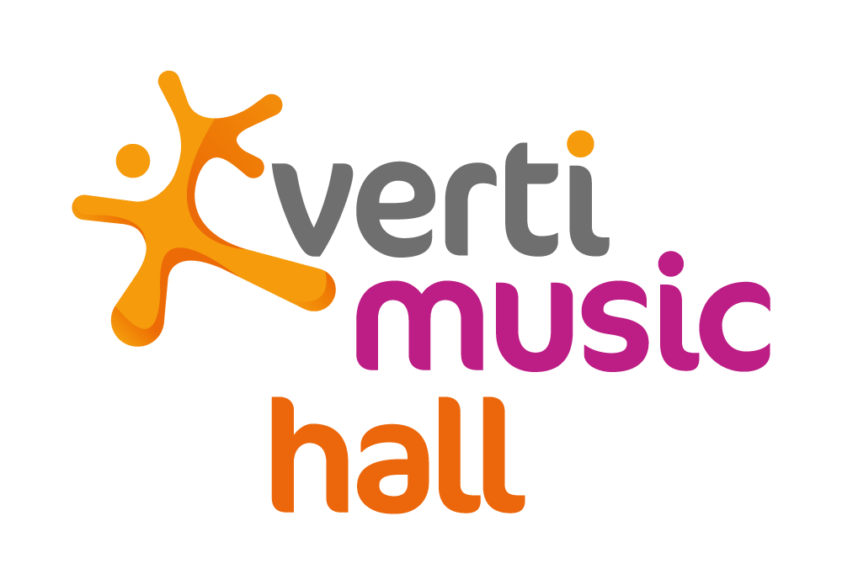

Verti Music Hall Opens for its First Night at the Mercedes Platz

Jack White plays a sold out show at the Verti Music Hall

The new Verti Music Hall will offer the atmosphere of an intimate venue, paired with the capabilities of a multi-functional arena

LOS ANGELES (October 15, 2018) - Making his return to Berlin, Jack White performed for the first time in the Verti Music Hall, Berlin’s newest concert venue at the Mercedes Platz on Friday, October 12, 2018.

Insurance company Verti and AEG have come together to bring the newest venue to Berlin. The Verti Music Hall at Mercedes Platz, will host concerts, shows and corporate events with a capacity for up to 4,350 people.

Attended by a maximum capacity crowd, Jack White at the Verti Music Hall was the perfect way to introduce the brand new venue to Berlin. The crowd got to experience the venue for the first time while discovering the vibrant new restaurants, bars, cafes, and bowling lanes of the Mercedes Platz, with a cinema and two hotels set to open later this fall.

Setting New Standards
Verti Music Hall will set new standards for event venues of comparable size with regards to customer experience and production. “We have spent a lot of time and resource during the planning and construction phase to ensure perfect sightlines and optimal sound, as well as the greatest possible flexibility for capacity, seating and different types of events”, says Michael Hapka, Vice President and Managing Director AEG Operations GmbH.

By adding the Verti Music Hall to its venue portfolio, AEG complements the offering of the neighboring Mercedes-Benz Arena, which is also owned and operated by the company. “The interior of the Music Hall is intimate and high-end in appearance, while the outer concourses have a more urban, industrial style. Verti Music Hall will enrich the Berlin venue landscape, for concert goers as well as for promoters and performing artists.”

Despite its intimate atmosphere, the Verti Music Hall is well equipped to host productions of varying technical requirements. Due to its design, the calculated rigging capacity will exceed 200 tones, which is more than most arenas can currently provide. AEG expects to host more than 100 events per year in the Verti Music Hall.

Verti Music Hall
The Verti Music Hall will be a central component of Mercedes Platz, an entertainment destination developed by the Anschutz Entertainment Group (AEG) for over 200 Million Euros in front of Mercedes-Benz Arena in Berlin. Mercedes Platz will become the vibrant center for the dynamically growing urban quarter along the East Side Gallery with an expected footfall of 20 Million people annually. Together with the Verti Music Hall the project will feature a state-of-the-art UCI Luxe movie theatre with 1.700 Seats, a lifestyle bowling lounge by Bowling World with 28 lanes, 20 cafés, restaurants and bars as well as two hotels – an Indigo Design hotel with about 118 rooms and a Hampton by Hilton hotel with 254 rooms and 10.000 square meters of office space. For more information: www.verti-music-hall.de

About AEG
Headquartered in Los Angeles, California, AEG is the world’s leading sports and live entertainment company. With offices on five continents, AEG operates in the following business segments: AEG Facilities, which is affiliated with or owns, manages or consults with more than 150 preeminent arenas, stadiums, theaters, clubs and convention centers around the world including The O2 Arena, the Sprint Center and the Mercedes-Benz Arenas; AEG Presents, which is dedicated to all aspects of live contemporary music performances, including producing and promoting global and regional concert tours, music and special events and world-renowned festivals; AEG Real Estate, which develops world-class venues, as well as major sports and entertainment districts like STAPLES Center and L.A. LIVE; AEG Sports, which is the world’s largest operator of sports franchises and high-profile sporting events; and AEG Global Partnerships, which oversees worldwide sales and servicing of sponsorships including naming rights, premium seating and other strategic partnerships. Through its worldwide network of venues, portfolio of powerful sports and music brands, AXS.com ticketing platform, AXS cable television channel and its integrated entertainment districts, AEG entertains more than 100 million guests annually. More information about AEG can be found at www.aegworldwide.com.

Media Contact:
Moritz Hillebrand
moritz.hillebrand@aegeurope.com
+49 (0) 30-20 60 70 82 50

Photo Caption:
AEG executives and fans alike flock to Verti Music Hall in Berlin for the venue’s inaugural concert by Jack White on October 12, 2018. (From left to right: Steve Schwenkglenks, General Manager, Barclaycard Arena Hamburg; John Langford, Vice President & General Manager, The O2, London; Marie Lindqvist, Vice President & General Manager, Stockholm Live; Christian D’Acuna, Head of Programming, The O2, London; Emma Bownes, Program Director, The O2, London; Darren Murphy, General Manager, Eventim Apollo, London; Sarah Myring, Front of House Manager, Eventim Apollo, London; John Drury, Vice President & General Manager, the SSE Wembley Arena, London; Kara James, WME; Paul Cheetham, Director Booking Verti Music Hall.)

