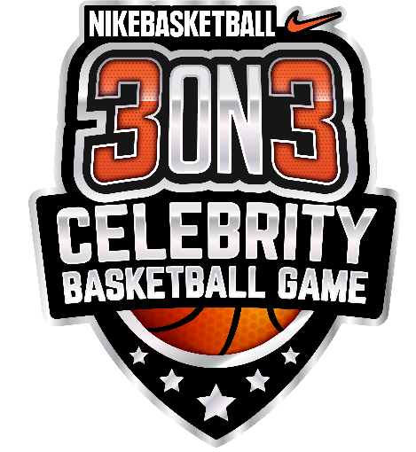
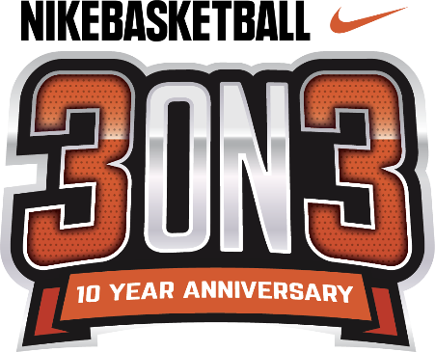

NIKE BASKETBALL 3ON3 TOURNAMENT
CELEBRATES 10TH ANNIVERSARY
AT L.A. LIVE, AUGUST 3-5

Nike 3ON3 Celebrity Basketball Game to Kick Off
California’s Largest 3-on-3 Street Basketball Tournament
on Friday, August 3

LOS ANGELES (July 10, 2018) – Nike Basketball 3ON3 Tournament, California’s largest street basketball tournament, will celebrate its 10th anniversary in its return to the streets of downtown Los Angeles and L.A. LIVE on Friday, August 3 - Sunday, August 5. The annual family-friendly, basketball weekend will kick-off with the Nike 3ON3 Celebrity Basketball Game in partnership with Dash Radio. The three-day event at L.A. LIVE is expected to feature more than 1,500 teams, 5,000 players and 25,000 spectators. For the second year in the tournament’s history, Nike 3ON3 Elite Division winners for both men and women will have the opportunity to compete in the Official 2019 USA Basketball 3x3 National Tournament. Festivities for the Nike 3ON3 Celebrity Basketball Game will begin at 7:30 p.m. on Friday, Aug. 3 in L.A. LIVE’s Microsoft Square.
Registration for the event is open to players of all ages and skill levels at nike3on3.com. Athletes are encouraged to sign up as soon as possible as brackets fill up quickly for what is expected to be the largest tournament registration to date. Three-on-three tournament games will take place on approximately 100 outdoor basketball courts with more than 15 interactive vendors and basketball-themed activities throughout the L.A. LIVE campus.
The Nike 3ON3 Celebrity Basketball Game in partnership with Dash Radio on Friday, Aug. 3 will lead off the weekend as today’s top Hip-Hop artists and celebrities take to the court to battle each other in L.A. LIVE’s Microsoft Square. The game will feature a special halftime performance in addition to exclusive prizes and photo opportunities for fans in attendance. DASH Radio will also be broadcasting live, all original content throughout the duration of the tournament. Tickets to the Nike 3ON3 Celebrity Basketball Game are available for purchase at Nike3on3.com/CelebGame. Prices for tickets range from $35 to $350 with courtside seats available plus limited VIP Packages for celebrity meet and greets. Teams that register for the Nike Basketball 3ON3 Tournament will receive a discount code for the event.
Complete team registration for the Nike Basketball 3ON3 Tournament starts at $180 for the Youth division (ages 8-12), $180 for the Teen division (ages 13-19), $200 for Adult division (ages 20 and over) and $240 for the Adult Elite division (ages 18 and over). Entry fees for all divisions will increase $10 respectively after July 11. Athletes of all ages and skill levels are invited to play. Each team must have a minimum of three players and a maximum of four players to participate. Registration for Special Olympics and Wheelchair divisions is open to all ages and is free of charge; teams can register by visiting Nike3on3.com.
Nike Basketball 3ON3 Tournament’s website features an upgraded and improved registration experience that allows players and captains to easily navigate. Captains can form their teams and make changes, free of charge, until Sunday, July 30 by 11:59 p.m. PST.
The 2017 tournament drew the most teams in the event’s history, nearly tripling in size from its first year. The tournament has become a Southern California tradition that attracts the best teams throughout the state and across the country. Around L.A. LIVE, STAPLES Center and along Chick Hearn Court, the Nike Basketball 3ON3 Tournament will be the home of approximately 100 outdoor basketball courts and an interactive Fan Fest to accommodate the thousands of athletes, guests and families participating and attending this year’s event.
As the largest 3-on-3 basketball tournament in California, Nike Basketball 3ON3 Tournament has continued to partner with leading brands in the sports industry. Official sponsors of the Nike Basketball 3ON3 Tournament include Nike Basketball, Blue Shield of California, Big 5 Sporting Goods, Spartan Race, Keck Medicine of USC, Powerade, Budweiser and FreshandWipe.
In its 10th anniversary, the Nike Basketball 3ON3 Tournament will feature new and unique sponsor activations. This year, attendees can test their endurance and athleticism on the Spartan Expo Obstacle Course—where participants can attempt for free, or pay $10 to race competitively for a T-shirt, Dog Tag and the chance to win $1,000 cash prize for the best overall finishing time of the weekend. Additionally, long-standing partner Big 5 Sporting Goods will present a designated practice court on-site, available to all tournament players and attendees throughout the weekend.
Opportunities and custom brackets for corporate wellness partners are available at a discounted rate and through the corporate donation program; several opportunities for organizations to support the local community by purchasing sponsored brackets to allow teams made up of individuals from underserved areas of Los Angeles in the Nike Basketball 3ON3 Tournament. Players of all ages, gender and skill levels are invited to participate in the Nike Basketball 3ON3 Tournament. Individual brackets will be divided into appropriate divisions based on a combination of skill, age, gender and height to achieve “level” competition.
The tournament features six main divisions of play: Adult Elite Division presented by Nike Basketball, Adult Division presented by Spartan Race, Teen Division presented by Big 5 Sporting Goods, Youth Division presented by Blue Shield of California, Special Olympics Division and Wheelchair Division. The player’s next grade for the Teen division must be 9th-12th and player’s next grade for the Youth division must be 3rd-8th. Adult, Teen and Youth divisions feature two competition levels: recreational and competitive. The Nike Elite Division will consist of two categories of players: Women’s and Men's Elite. Brackets will be formed based on these criteria and those delineated above. Participants can register their teams online at nike3on3.com.
The Nike Basketball 3ON3 Tournament is free and open to the public. The three-day experience will feature a variety of events at the Nike Center Court located within Microsoft Square at L.A. LIVE, including the highly anticipated Nike Slam Dunk Contest, a 3-Point Contest, Skills Challenge in addition to more than 15 interactive vendors and basketball-themed activities. Complete information about registration, eligibility, rules and bracketing can be found at the official Nike Basketball 3ON3 Tournament website, Nike3on3.com. For additional information and up to the minute details, follow the official Twitter account at twitter.com/nikebball3on3, the official Facebook page at facebook.com/nike3on3 and the official Instagram account at @nike3on3.

About L.A. LIVE
L.A. LIVE is a 4 million square-foot, $3 billion downtown Los Angeles sports and entertainment district adjacent to STAPLES Center and the Los Angeles Convention Center featuring The Novo by Microsoft, a 2,300 capacity live music venue, Microsoft Theater, a 7,100-seat live theatre, a 54-story, 1001-room convention “headquarters” destination (featuring The Ritz-Carlton, Los Angeles and JW Marriott Los Angeles at L.A. LIVE hotels and 224 luxury condominiums – The Ritz-Carlton Residences at L.A. LIVE – all in a single tower), the GRAMMY Museum, the 14-screen Regal Cinemas L.A. LIVE: A Barco Innovation Center theatre, broadcast facilities for ESPN along with entertainment, residential, restaurant and office space.

Developed by Los Angeles-based AEG, L.A. LIVE, considered to be the nation’s most active ‘live content and event campus,’ has become the region’s most in-demand and busiest hospitality location throughout the past 10 years, featuring 260,480 sf of conference center and ballroom facilities, world-class restaurants including WP24, Fleming’s Prime Steakhouse & Wine Bar, Katsuya, Lawry’s Carvery, Rock ‘N Fish, Rosa Mexicano, Starbucks, Triple 8, Glance Restaurant, Smashburger, Live Basil Pizza, Tom’s Urban 24, Yard House, Wolfgang Puck Bar & Grill and BOCA at the Conga Room and others; 100,000 sf special events deck, the famous Lucky Strike Lanes and Lounge, the celebrity owned Conga Room, a one-of-a-kind GRAMMY Museum, saluting the history of music and the genre’s best known awards show all centered around Microsoft Square, a 40,000 sf outdoor event space.

With Microsoft Theater and Microsoft Square which came on-line in October, 2007, and the hotel, residential and meeting space components opened as of April, 2010 combined with the assets, resources and infrastructure of STAPLES Center and the Los Angeles Convention Center, L.A. LIVE showcases more events, award shows, sporting competitions, concerts and hospitality options than any other destination in the world.

About Dash Radio:
Dash Radio is the global leader in curated, lean-back audio experiences. Since it's 2015 launch, Dash has become the world's largest all-original digital broadcaster, empowering many of the world's biggest artists, influencers and brands to take radio over the top, directly to fans, without fees or subscriptions. Featuring over 80 curator-championed original stations, Dash is available on 50+ platforms - inside nearly every connected car service, smart home product and IoT device. With no traditional commercials, Dash Radio offers fans the perfected music discovery experience free of charge, while offering brands a more authentic and effective way to engage these audiences worldwide. For more information, please visit www.dashradio.com.

# # #
Media Contacts:
Allegra Batista
(213) 259-9953
abatista@aegworldwide.com

