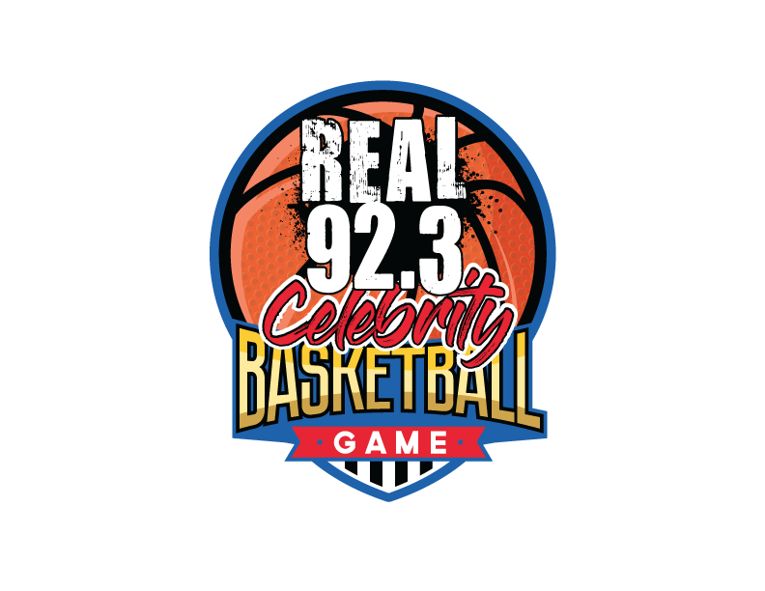
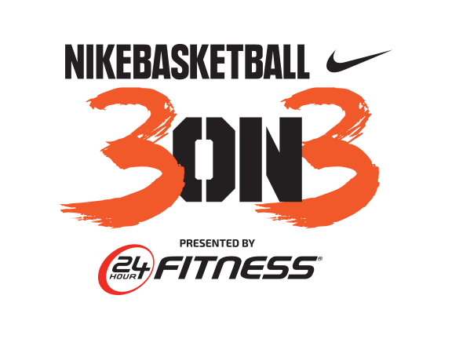

NINTH ANNUAL NIKE BASKETBALL 3ON3 TOURNAMENT PRESENTED BY 24 HOUR FITNESS TO
RETURN TO L.A. LIVE, AUGUST 4-6

iHeartMedia Los Angeles’ Real 92.3 Celebrity Basketball Game to
Kick-Off California’s Largest 3-on-3 Street Basketball Tournament on Friday, August 4

LOS ANGELES (June 29, 2017) – Nike Basketball 3ON3 Tournament presented by 24 Hour Fitness, California’s largest street basketball tournament, will return to the streets of downtown Los Angeles and L.A. LIVE for the ninth consecutive year and will tip-off with the debut of the Real 92.3 Celebrity Basketball Game in partnership with the Nike Basketball 3ON3 Tournament benefiting Follow the Dream Foundation, a non-profit established by DJ Damage, on-air personality and DJ for iHeartMedia Los Angeles’ Real 92.3. The three-day event will take place Friday, August 4 - Sunday, August 6 at L.A. LIVE and is expected to feature more than 1,500 teams, 5,000 players and 25,000 spectators. Kicking off L.A. LIVE’s annual family friendly basketball event, the Real 92.3 Celebrity Basketball Game will tip-off the weekend festivities at 7:30 p.m. on Friday, Aug. 4 in L.A. LIVE’s Microsoft Square.
Players of all ages and skill levels can now register at nike3on3.com. Athletes are encouraged to sign up as soon as possible as brackets fill up quickly for what is expected to be the largest tournament registration to date. Three-on-three tournament games will take place on approximately 100 outdoor basketball courts with more than 15 interactive vendors and basketball-themed activities throughout the L.A. LIVE campus.
Debuting for the first time will be the highly anticipated Real 92.3 Celebrity Basketball Game in partnership with the Nike Basketball 3ON3 Tournament, leading off the weekend on Friday, Aug. 4 and benefitting DJ Damage’s non-profit, Follow the Dream Foundation. Coached by Nick Cannon and Real 92.3 on-air personality Big Boy, today’s top Hip-Hop artists and celebrities including Tyga, The Game, Omarion, Eric Bellinger and more will take to the court to battle each other in L.A. LIVE’s Microsoft Square. (All talent is subject to change.) The game will feature a special halftime performance and there will be exclusive prizes and photo opportunities for fans in attendance. Tickets to the Real 92.3 Celebrity Basketball Game are available for purchase at Nike3on3.com/REAL923. Prices for tickets range from $35 to $350 with courtside seats available plus limited VIP Packages for celebrity meet and greets. Teams that register for the Nike Basketball 3ON3 Tournament will receive a discount code for the event.
Complete team registration for the Nike Basketball 3ON3 Tournament starts at $180 for the Youth division (ages 8-12), $180 for the Teen division (ages 13-19), $200 for Adult division (ages 20 and over) and $240 for the Adult Elite division (ages 18 and over). Entry fees for all divisions will increase $10 respectively after July 7. All ages and skill levels are invited to play. Each team must have a minimum of three players and a maximum of four players to participate. Registration for Special Olympics and Wheelchair divisions is open to all ages and is free of charge; teams can register by visiting Nike3on3.com.
Nike Basketball 3ON3 Tournament’s website features an upgraded and improved registration experience that allows players and captains to easily navigate. Captains can form their teams and make changes, free of charge, until Sunday, July 30 by 11:59pm PST.
The 2016 tournament drew the most teams in the event’s history, nearly tripling in size from its first year. The tournament has become a Southern California tradition that attracts the best teams from California and across the country. Around L.A. LIVE, STAPLES Center and along Chick Hearn Court, the Nike Basketball 3ON3 Tournament will be the home of approximately 100 outdoor basketball courts and an interactive Fan Fest to accommodate the thousands of athletes, guests and families participating and attending this year’s event.
As the largest 3-on-3 basketball tournament in California, Nike Basketball 3ON3 Tournament has continued to partner with leaders in the sports industry to continue to deliver valuable assets for all participants. Official sponsors of the Nike Basketball 3ON3 Tournament include Nike Basketball, 24 Hour Fitness, Big 5 Sporting Goods, Bodybuilding.com, Keck Medicine of USC, Toyota, FreshandWipe, KT Tape, and Hippeas.
Opportunities and custom brackets for corporate wellness partners are available at a discounted rate and through the corporate donation program; several opportunities for organizations to support the local community by purchasing sponsored brackets to allow teams made up of individuals from underserved areas of Los Angeles in the Nike Basketball 3ON3 Tournament. Players of all ages, gender and skill levels are invited to participate in the Nike Basketball 3ON3 Tournament. Individual brackets will be divided into appropriate divisions based on a combination of skill, age, gender and height to achieve “level” competition.
The tournament features six main divisions of play: Adult Elite Division presented by Nike Basketball, Adult Division, Teen Division presented by Big 5 Sporting Goods, Youth Division, Special Olympics Division and Wheelchair Division. The player’s next grade for the Teen division must be 9th-12th and player’s next grade for the Youth division must be 3rd-8th. Adult, Teen and Youth divisions feature two competition levels: recreational and competitive. The Nike Elite Division will consist of two categories of players: Women’s and Men's Elite. Brackets will be formed based on these criteria and those delineated above. Participants can register their teams online at nike3on3.com.
The Nike Basketball 3ON3 Tournament is free and open to the public. The three-day experience will feature a variety of events at the Nike Center Court located within Microsoft Square at L.A. LIVE, including the highly anticipated Nike Slam Dunk Contest, 24 Hour Fitness 3-Point Contest, BodyBuilding.com Skills Challenge, and more than 15 interactive vendors and basketball-themed activities. Complete information about registration, eligibility, rules and bracketing can be found at the official Nike Basketball 3ON3 Tournament website, Nike3on3.com. For additional information and up to the minute details, follow the official Twitter account at twitter.com/nikebball3on3, the official Facebook page at facebook.com/nike3on3 and the official Instagram account at @nike3on3.

About L.A. LIVE
L.A. LIVE is a 4 million square foot / $3 billion downtown Los Angeles sports and entertainment district adjacent to STAPLES Center and the Los Angeles Convention Center featuring The Novo by Microsoft, a 2,300 capacity live music venue, Microsoft Theater, a 7,100-seat live theatre, a 54-story, 1001-room convention “headquarters” destination (featuring The Ritz-Carlton, Los Angeles and JW Marriott Los Angeles at L.A. LIVE hotels and 224 luxury condominiums – The Ritz-Carlton Residences at L.A. LIVE – all in a single tower) , the GRAMMY Museum, the 14-screen Regal Cinemas L.A. LIVE: A Barco Innovation Center theatre, broadcast facilities for ESPN along with entertainment, residential, restaurant and office space.

Developed by Los Angeles-based AEG, L.A. LIVE, considered to be the nation’s most active ‘live content and event campus,’ has become the region’s most in-demand and busiest hospitality location featuring 260,480 sf of conference center and ballroom facilities, world-class restaurants including WP24, Fleming’s Prime Steakhouse & Wine Bar, Katsuya, Lawry’s Carvery, Rock ‘N Fish, Rosa Mexicano, Starbucks, Triple 8, Ford’s Filling Station, Smashburger, Live Basil Pizza, Tom’s Urban 24, Yard House, Wolfgang Puck Bar & Grill and BOCA at the Conga Room and others; 100,000 sf special events deck, the famous Lucky Strike Lanes and Lounge, the celebrity owned Conga Room, a one-of-a-kind GRAMMY Museum, saluting the history of music and the genre’s best known awards show all centered around Microsoft Square, a 40,000 sf outdoor event space.

With Microsoft Theater and Microsoft Square which came on-line in October, 2007, and the hotel, residential and meeting space components opened as of April, 2010 combined with the assets, resources and infrastructure of STAPLES Center and the Los Angeles Convention Center, L.A. LIVE showcases more events, award shows, sporting competitions, concerts and hospitality options than any other destination in the world.

About Real 92.3
Real 92.3 is owned and operated by iHeartMedia. With over a quarter of a billion monthly listeners in the U.S. and over 85 million social followers, iHeartMedia has the largest national reach of any radio or television outlet in America. As the leader in multiplatform connections, it also serves over 150 local markets through 858 owned radio stations, and the company’s radio stations and content can be heard on AM/FM, HD digital radio, satellite radio, on the Internet at iHeartRadio.com and on the company’s radio station websites, on the iHeartRadio mobile app, in enhanced auto dashes, on tablets, wearables and smartphones, and on gaming consoles.

iHeartRadio, iHeartMedia’s digital radio platform, is the fastest growing digital audio service in the U.S. and offers users thousands of live radio stations, personalized custom artist stations created by just one song or seed artist and the top podcasts and personalities. With over a billion downloads, iHeartRadio reached 100 million registered users faster than any other radio or digital music service.

iHeartMedia’s platforms include radio broadcasting, online, mobile, digital and social media, podcasts, personalities and influencers, live concerts and events, syndication, music research services and independent media representation. iHeartMedia is a division of iHeartMedia, Inc. (OTCBB: IHRT). Visit iHeartMedia.com for more company information.​

# # #
Media Contacts:
Allegra Batista
(213) 763-7738
abatista@aegworldwide.com

