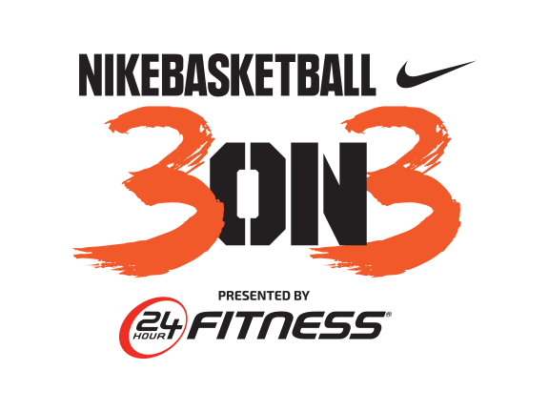

NINTH ANNUAL NIKE BASKETBALL 3ON3 TOURNAMENT PRESENTED BY
24 HOUR FITNESS BRINGS MORE THAN 1,500 TEAMS TO L.A. LIVE; CONCLUDES WITH TOURNAMENT FIRST

California’s largest 3-on-3 street basketball tournament’s
championship games serve for the first time as official qualifier for
2018 USA Basketball 3X3 National Tournament

LOS ANGELES (August 7, 2017) – The Ninth Annual Nike Basketball 3ON3 Tournament presented by 24 Hour Fitness at L.A. LIVE brought more than 1,500 teams from around the country to compete in more than 1,400 games and concluded yesterday with a tournament first with the winners of the women’s Nike Elite Division and the men’s Nike Elite Division qualifying to compete in the 2018 USA Basketball 3X3 National Tournament in Colorado Springs.

The women’s Nike Elite Division was won by team Bye Felicia consisting of players Danika Dale, Mariesa Greene, Amanda Frost and Kristen McCarthy. The men’s Nike Elite Division was won by team Ariel Slow & Steady consisting of players Craig Moore, Kareem Maddox, Dan Mavraides and Jimmy Sherburne. In addition to qualifying to compete in the 2018 USA Basketball 3X3 National Tournament in Colorado Springs, and potentially represent the United States of America in the 2018 3x3 World Cup, each player from the winning teams in the Elite Division also won a $500 American Express gift card.

Throughout the weekend, more than 5,000 players competed on the surrounding streets of L.A. LIVE and STAPLES Center throughout downtown Los Angeles in California’s largest 3-on-3 street basketball tournament, with more than 25,000 fans and spectators cheering them on.

The entertainment-packed weekend kicked off on Friday, Aug. 4 in L.A. LIVE’s Microsoft Square with the debut of the Real 92.3 Celebrity Basketball Game benefiting Follow the Dream Foundation, a non-profit established by DJ Damage, on-air personality and DJ for iHeartMedia Los Angeles’ Real 92.3. The two teams coached by Nick Cannon and Real 92.3 on-air personality Big Boy featured hip-hop artists, actors, former NBA players and professional slam dunkers, such as Tyga, The Game, Omarion, Sage the Gemini and more and were cheered on by 800 fans in the stands.

Saturday’s competition among the tournament’s seven divisions (youth, teen, adult, adult elite, corporate challenge, wheelchair and Special Olympics) was highlighted by the fan-favorite Nike Slam Dunk Contest, which drew the largest crowds of the day as internationally known slam dunkers Chris Staples, Carlos Smothers, Young Hollywood and Reemix showed off their high-flying skills. Reemix took first place after receiving top marks across the board from the judges.

“We are thrilled that the Nike Basketball 3ON3 Tournament continues to grow and has become one of L.A. LIVE’s most popular events in the downtown Los Angeles community. With our Elite Division now serving as an official qualifier for the 2018 USA Basketball 3X3 National Tournament, and approaching the 10th anniversary of the Tournament next year, we look forward to continuing to set apart this event as the best 3-on-3 tournament in the state,” said Ryan Golden, Senior Director of Business Operations, L.A. LIVE. “This wouldn’t be possible without our hardworking staff, volunteers, sponsors and of course, the competing athletes and their families who bring so much energy and heart to the event.”

The Ninth Annual Nike Basketball 3ON3 Tournament presented by 24 Hour Fitness once again drew an impressive number of teams and fans and has tripled in size from its inaugural year, becoming a Southern California tradition that now attracts the best teams from around the country.

Official sponsors of the Nike Basketball 3ON3 Tournament presented by 24 Hour Fitness include 8th year title sponsor Nike, 24 Hour Fitness, Carl's Jr., Big 5 Sporting Goods, Keck Medicine of USC, Budweiser, Zico, Toyota, Bodybuilding.com, FRESHANDWIPE, KT Tape, Hippeas, LA Times, and RX Bar.

Plans for the 10th Annual Nike Basketball 3ON3 Tournament at L.A. LIVE are under way and will be announced in the coming months.

About L.A. LIVE
L.A. LIVE is a 4 million square foot / $3 billion downtown Los Angeles sports and entertainment district adjacent to STAPLES Center and the Los Angeles Convention Center featuring The Novo by Microsoft, a 2,300 capacity live music venue, Microsoft Theater, a 7,100-seat live theatre, a 54-story, 1001-room convention “headquarters” destination (featuring The Ritz-Carlton, Los Angeles and JW Marriott Los Angeles at L.A. LIVE hotels and 224 luxury condominiums – The Ritz-Carlton Residences at L.A. LIVE – all in a single tower) , the GRAMMY Museum, the 14-screen Regal Cinemas L.A. LIVE: A Barco Innovation Center theatre, broadcast facilities for ESPN along with entertainment, residential, restaurant and office space.

Developed by Los Angeles-based AEG, L.A. LIVE, considered to be the nation’s most active ‘live content and event campus,’ has become the region’s most in-demand and busiest hospitality location featuring 260,480 sf of conference center and ballroom facilities, world-class restaurants including WP24, Fleming’s Prime Steakhouse & Wine Bar, Katsuya, Lawry’s Carvery, Rock ‘N Fish, Rosa Mexicano, Starbucks, Triple 8, Ford’s Filling Station, Smashburger, Live Basil Pizza, Tom’s Urban 24, Yard House, Wolfgang Puck Bar & Grill and BOCA at the Conga Room and others; 100,000 sf special events deck, the famous Lucky Strike Lanes and Lounge, the celebrity owned Conga Room, a one-of-a-kind GRAMMY Museum, saluting the history of music and the genre’s best known awards show all centered around Microsoft Square, a 40,000 sf outdoor event space.

With Microsoft Theater and Microsoft Square which came on-line in October, 2007, and the hotel, residential and meeting space components opened as of April, 2010 combined with the assets, resources and infrastructure of STAPLES Center and the Los Angeles Convention Center, L.A. LIVE showcases more events, award shows, sporting competitions, concerts and hospitality options than any other destination in the world.

# # #

Please use the following link to view photos from the event:
https://www.dropbox.com/sh/6qld7pqgt22gzng/AABerdW94DwHA1bNYEofCGzza?dl=0

Media Contact
Allegra Batista
abatista@aegworldwide.com
213-259-9953

