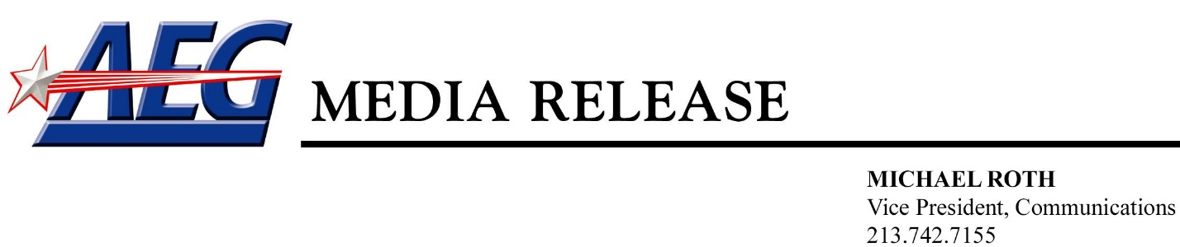

AEG TO ACQUIRE NASHVILLE SITE TO DEVELOP MIXED-USE ENTERTAINMENT DISTRICT

Owner and Operator of L.A. LIVE
Signs-On to Develop New Transformative Nashville Yards Destination

NASHVILLE & LOS ANGELES (June 19, 2017) – AEG, the world’s leading sports and live entertainment company, and Southwest Value Partners (SWVP) announced today that the two companies have entered into an agreement that will allow AEG to purchase a four-acre parcel of land to develop a new mixed-use entertainment district at SWVP’s Nashville Yards in downtown Nashville, TN.

The agreement further expands AEG’s portfolio of mixed-use entertainment districts which includes such renowned destinations as L.A. LIVE, The O2 (London, England) and Mercedes-Benz Platz (currently under construction in Berlin, Germany). AEG will work closely with SWVP to integrate all aspects of the new entertainment district development at the center of the Nashville Yards’ site into the infrastructure, architecture and pedestrian connectivity of SWVP’s already announced project, resulting in a dynamic mixed-use community that will feature a 15-acre modern urban retail, hospitality, creative Class A office, residential and entertainment offering in the heart of Nashville.

AEG’s planned mixed-use entertainment district will be anchored by a 4,000-capacity music venue, a flagship Regal Cinemas luxury theatre complex, a 600-700-capacity live entertainment club, an approximately 240-room boutique hotel, and a variety of other entertainment and food and beverage offerings.

SWVP and AEG will continue to work closely with Nashville’s city leaders to ensure that all offerings at Nashville Yards will meet the city’s development objectives while honoring Nashville’s history and heritage in its use of materials, scale and eclectic charm.

“For several years, AEG has been looking for the right venue development opportunity in Nashville, one of the fastest growing cities in the country,” said Jay Marciano, Chief Operating Officer, AEG and Chairman and CEO, AEG Presents. “A development offering like this has to not just be special, but be remarkable. AEG is very pleased to be partnering with Southwest Value Partners and the City of Nashville in this exciting entertainment venture.”

“Regal is thrilled to partner with AEG in bringing a new state-of-the-art entertainment destination to our loyal customers in Nashville,” stated Todd Boruff, Senior Vice President of Real Estate for Regal Entertainment Group. “The Nashville Yards theatre will feature a new level in moviegoing, including luxury recliners in every auditorium for our guests to enjoy. We are truly excited to be a part of this new entertainment district and connected to the vibrant charm that downtown Nashville offers.”

SWVP’s Nashville Yards is a multi-phase office, retail, hospitality, entertainment and residential project that will span the western edge of downtown and stretch from Broadway north past Church Street. The first site within Nashville Yards will open in 2020 with a 591-room premium, full service Hyatt Regency hotel featuring more than 65,000 square feet of group meeting space, a world-class spa and culinary experiences. The Hyatt Regency will anchor the northwest corner of Broadway and 10th Avenue.

The AEG-developed entertainment district will initially break-ground on four acres to be located at 10th Avenue between Commerce Street and Church Street. The SWVP and AEG agreement also provides an option for AEG to acquire an additional, adjacent 1.5-acre parcel for further mixed-used development, including creative office, residential, hotel and retail.

“We know AEG to be the world’s leading sports and live entertainment company and are thrilled to collaborate together to bring this mixed-use entertainment district to Nashville Yards. Today’s announcement confirms our vision for Nashville Yards as well as the incredibly positive trajectory of the city,” said SWVP Managing Partners Cary Mack and Mark Schlossberg in a joint statement.

The new entertainment district will be within walking distance to the Music City Center, the Country Music Hall of Fame and Museum, Bridgestone Arena, the Frist Center for the Visual Arts, The Johnny Cash Museum, and Nashville’s Honky Tonks. The development is also convenient to Nashville’s central business district, the Tennessee State Capitol, the Gulch, Vanderbilt, Tennessee State and Belmont Universities, and major corporations in the area, including Bridgestone, Hospital Corporation of America, Dollar General, Nissan North America, and UnderArmour.

About AEG:
Headquartered in Los Angeles, California, AEG is the world’s leading sports and live entertainment company. With offices on five continents, AEG operates in the following business segments: AEG Facilities, which is affiliated with or owns, manages or consults with more than 120 preeminent arenas, stadiums, theaters, clubs and convention centers around the world including The O2 Arena, the Sprint Center and the Mercedes-Benz Arenas; AEG Presents, which is dedicated to all aspects of live contemporary music performances, including producing and promoting global and regional concert tours, music and special events and world-renowned festivals; AEG Real Estate, which develops world-class venues, as well as major sports and entertainment districts like STAPLES Center and L.A. LIVE; AEG Sports, which is the world’s largest operator of sports franchises and high-profile sporting events; and AEG Global Partnerships, which oversees worldwide sales and servicing of sponsorships including naming rights, premium seating and other strategic partnerships. Through its worldwide network of venues, portfolio of powerful sports and music brands, AXS.com ticketing platform, AXS cable television channel and its integrated entertainment districts, AEG entertains more than 100 million guests annually. More information about AEG can be found at www.aegworldwide.com.

ABOUT SOUTHWEST VALUE PARTNERS

For more information about Southwest Value Partners, please visit www.swvp.com.

Contacts:

For AEG: For Southwest Value Partners:

Michael Roth Charles Robert Bone

(213) 742-7155 (615) 238-6394

mroth@aegworldwide.com crb@bonelaw.com

