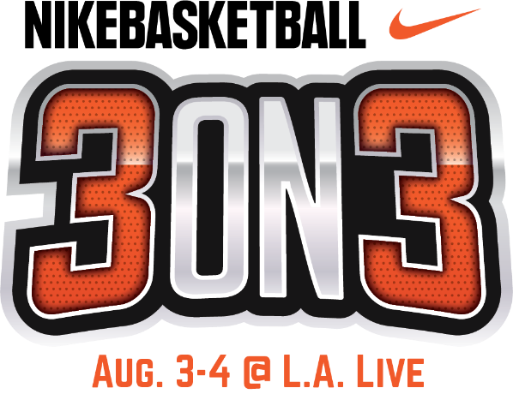

NIKE BASKETBALL 3ON3 TOURNAMENT AT L.A. LIVE TO WELCOME
OLYMPIC HOPEFULS LOOKING TO 2020 TOKYO GAMES

Defending Nike Basketball 3ON3 Champions Return Following
2019 USA Basketball 3x3 National Tournament Win
Hoping for Fourth Victory, Aug. 3-4

Tournament to Serve as Official FIBA 3X3 Satellite Tournament

LOS ANGELES (Aug. 1, 2019) – The 11th annual Nike Basketball 3ON3 Tournament, California’s largest street basketball tournament, will return to downtown Los Angeles and L.A. LIVE this weekend, August 3-4, to welcome athletes of all ages and levels of play, including Olympic hopefuls competing in the tournament’s Elite Division aiming to ultimately qualify for the first-ever 3X3 basketball event at the upcoming 2020 Olympic Games in Tokyo.

For the first time in the Nike Basketball 3ON3 Tournament’s history, the Men’s Elite division will serve as an official International Basketball Federation (FIBA) 3X3 Satellite Tournament, with the winners guaranteed an entry into FIBA’s upcoming Edmonton Challenger event on September 28-29 where they can ultimately qualify to advance to the FIBA 3X3 World Tour Nanjing Masters in China on October 12 and 13 – bringing them one step closer to their Olympic dreams of representing the USA in Tokyo.

Beginning this Saturday, August 3 at 9 a.m., L.A. LIVE will welcome more than 1,500 teams, 5,000 players, and 25,000 spectators to participate in the annual event. Prizes will be awarded to winners of each of the divisions with champions of the Men’s Elite division also receiving airfare, lodging, ground transportation and a meal allowance along with an entry (one of only 16 qualifying teams) to the FIBA 3X3 Edmonton Challenger Event.

“The Nike Basketball 3ON3 Tournament at L.A. LIVE is the largest area event to celebrate the continuing emergence of the newest Olympic Sport that is taking the basketball world by storm,” said Paul Sir, Director, FIBA 3x3 North America. “The opportunity for players and fans to experience the fast pace and intense action in this world class showcase at L.A. LIVE, clearly demonstrates how 3x3 is the basketball game of both the present and future!”

“We are thrilled that due to our tournament’s proven track record, the Nike Basketball 3ON3 Tournament has been designated an official FIBA 3X3 Satellite Tournament,” said Ryan Golden, Commissioner, Nike Basketball 3ON3 Tournament at L.A. LIVE. “This designation has already attracted athletes from across the nation who all share the dream of competing in the first-ever FIBA 3x3 tournament in the 2020 Olympic Games in Tokyo.”

Hoping to repeat their championship performances from the 2018, 2017 and 2015 Nike Basketball 3ON3 Tournament at L.A. LIVE, Los Angeles native Dan Mavraides and his TEAM ARIEL SLOW & STEADY look to not only defend their title in the Men’s Elite Division this weekend at L.A. LIVE but in doing so, strengthen their chances of qualifying for the debut of 3x3 basketball in the 2020 Tokyo Olympics.

“The Nike Basketball 3ON3 Tournament at L.A. LIVE is a staple of my summer,” said Mavraides. “The elite division brings out some of the best players – of all ages – in the city and state, to compete for bragging rights – and now the chance to play in the Edmonton Challenger!”

“As an LA native, there are a lot of bragging rights to winning this tournament, but with a year to go until the debut of FIBA 3x3 in the 2020 Olympic Games, my eyes are fixed on being one of four players selected to represent the USA in Tokyo in 2020.”

Upon winning the Nike Basketball 3ON3 Tournament last year, Mavraides’ team qualified for and went on to win the 2019 USA Basketball 3x3 Tournament – claiming the national title for the third consecutive year.

Since winning their third National 3x3 Championship in May, the team has competed in more than eight countries and is currently ranked the No. 1 3x3 team in the United States and No. 8 in the world.

The Nike Basketball 3ON3 Tournament is free and open to the public to attend. The three-day experience will feature a variety of events at the Nike Center Court located within Xbox Plaza at L.A. LIVE, including the highly anticipated Nike Slam Dunk Contest, a 3-Point Contest, Skills Challenge in addition to more than 15 interactive vendors and basketball-themed activities. To participate in playing in the tournament, complete information about registration, eligibility, rules and bracketing can be found at the official Nike Basketball 3ON3 Tournament website, Nike3on3.com. For additional information and up to the minute details, follow the official Twitter account at twitter.com/nikebball3on3, the official Facebook page at facebook.com/nike3on3 and the official Instagram account at @nike3on3.

For additional Nike Basketball 3ON3 Tournament Media Assets, please visit our website.

Media Contact:
Allegra Batista, AEG
abatista@aegworldwide.com
213-259-9953

