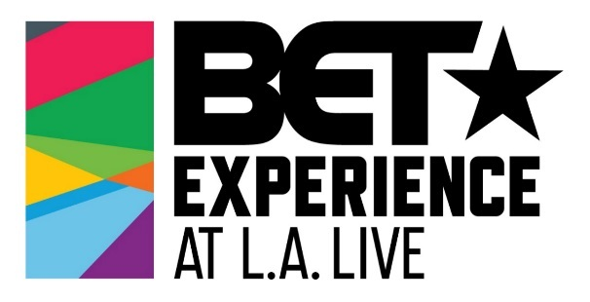

BET EXPERIENCE YOUTH PROGRAM PRESENTED BY AEG TO HOST EXCLUSIVE MUSIC INDUSTRY PANEL FEATURING ROBIN THICKE, RAPSODY,
INDUSTRY EXECUTIVES AND MORE

50 Los Angeles-Area High School Students to Receive Career Advice from
Music Artists, Executives and Industry Professionals in Exclusive Panel

Saturday, June 22 at 2:30 p.m.

WHAT: AEG and BET are teaming up to host a private music industry panel for the 50 high school students from the greater Los Angeles Area selected to participate in this year’s BET Experience Youth Program presented by AEG, in addition to BET Experience Youth Program alumni from previous years.

During the panel, students will hear from music artists, writers, producers and executives and will have the opportunity to ask career advice and gain a larger understanding of the various roles within the music industry.

This is the second year that AEG and BET have curated an exclusive music industry panel during the BET Experience Youth Program presented by AEG.

WHO:
- Robin Thicke (Singer-Songwriter, Producer)
- Rapsody (Rapper)
- Kesington “Kes” Kross (Songwriter, Producer)
- Aleicia Nicole (Songwriter)
- Crystal Johnson (Panel Moderator)
(NOTE: All talent subject to change)

WHEN: Saturday, June 22, 2019
2 p.m. Media Check-In
2:30 - 4 p.m. BET Experience Youth Program - Music Industry Panel
*Photo & b-roll opportunities

WHERE: STAPLES Center – Clippers Lounge
1111 S Figueroa St.
Los Angeles, CA 90015

MEDIA OPPS:
- B-roll of Music Industry Panel
- B-roll of Q&A with panelists and BET Experience Youth Program high school students and alumni
- Speakers from AEG, BET, panelists, Youth Program participants available for interview

MORE INFO: Since the inception of BET Experience at L.A. LIVE in 2012, AEG, the world’s leading sports and live entertainment company and BET Networks have provided more than 300 students throughout the greater Los Angeles area with an in-depth look at the entertainment industry and behind-the-scenes access to the BET Experience at L.A. LIVE and the BET Awards through the BET Experience Youth Program.

TO COVER: Please note you must RSVP to cover this event.

MEDIA CONTACT:
Allegra Batista
AEG
abatista@aegworldwide.com
(213) 763-7738

