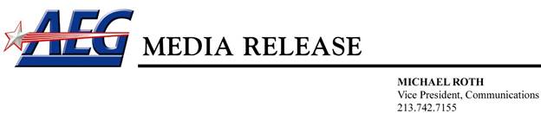

**A.S.O. joins forces with AEG in the German market**

(May 16, 2017) Amaury Sport Organisation (A.S.O.), and Anschutz Entertainment Group (AEG) have agreed on a strategic partnership around their common goal to develop cycling in Germany. As part of the partnership, AEG will work closely with A.S.O. on its cycling business in the German market, which includes to launch a new Deutschland Tour (Tour of Germany) in August 2018 and the annual Eschborn-Frankfurt classic, the 56th edition of which took place, as part of the World Tour for the first time, on May 1, 2017. The joint announcement was made today by representatives of A.S.O. and AEG at the conclusion of Stage 2 of the Amgen Tour of California which is owned by AEG and organized in partnership with A.S.O.

As part of the comprehensive partnership between the global sports organizations, AEG will lead the sponsorship sales process for both the Eschborn-Frankfurt classic and the Deutschland Tour (Tour of Germany), an innovative concept which is designed as a bike festival that bridges the gap between professional and everyday cycling (Deutschland. Deine Tour).

**Yann Le Moënner**, Managing Director of A.S.O.: “Our strategic partnership with AEG underlines how committed we are to the German market. The Grand Départ 2017 in Düsseldorf, the just renewed partnership with ARD on broadcasting the Tour de France, the addition of the Eschborn-Frankfurt classic to the family of A.S.O. races and the new Deutschland Tour are all for themselves significant milestones to support the growth of cycling in Germany. We are excited to join forces with AEG, who will be a strong partner to achieve this vision”.

**Steven A. Cohen**, Chief Strategic Officer, AEG: “The German market has been core to AEG’s worldwide portfolio of sports, entertainment and real estate properties for more than a decade and today’s announcement further builds on our collection of assets in Germany. Partnering with A.S.O., the global leaders in cycling and numerous other major international competitions, will bring together two organizations with a shared vision and complementary assets and resources that will result in two outstanding and unique events for Germany and cycling fans globally.”